WoW - MWS
TINYTODE'S IN-DEPTH MAGIC WORKSTATION/WOW INSTALLATION/FAQ
--------------------------------------------------------------------------------------------------------
Version 10.0
(Released: September 2010)

(The latest version of this FAQ and other useful information can always be
found on my web page: http://mws.infogathering.com)

*(For the latest changes, see the Version History at the end of this FAQ)*

TABLE OF CONTENTS
=================

Introduction

Section 1: Installation
A) Necessary Files
B) Tiering of Files
C) Patching for WoW
D) Opening the Master Base Database

Section 2: Utilizing Deck Builder Program
A) Creating a Deck
B) Making a Side Board
C) Copying a Deck

Section 3: Starting a Game Online
A) Loading a Deck
B) Creating a Username
C) Joining a Server
D) Joining / Hosting a Game

Section 4: Playing a Game

Section 5: FAQ’s (Coming Soon)

Section 6: Version History
Introduction

Welcome to my first incarnation of an Installation Guide / FAQ. Please bear with me on this endeavor as I’ve never written such an in-depth guide. I will attempt to show you how to enjoy WoW TCG on Magic Workstation. If this is your first time using this guide, please read it in its entirety before attempting to play. Good luck and Happy Gaming!

What this guide will do:
- Help you install WoW Patches and Magic Workstation
- Teach you how to utilize the Magic Workstation Programs
- Teach you how to start and join games on MWS Play

What this guide will NOT do:
- Teach you how to build a competitive deck
- Teach you how to use strategy to out play opponents
- Teach you how to win games

Section 1
Installation

A) Necessary Files

Before you begin, you will need to download and install the following files in order:
Magic Workstation: http://www.magicworkstation.com/download/mws094f.exe
Patches: http://mws.infogathering.com/files/Full_Install_Part_1.exe
http://mws.infogathering.com/files/Full_Install_Part_2.exe
http://mws.infogathering.com/files/Full_Install_Part_3.exe

B) Tiering of Files

I would highly recommend that, when prompted, you install all files to the default locations and overwrite when prompted. For reference, Magic Workstation should be installed to:

C:\Program Files\Magic Workstation

The patches are my own creation, and come equipped with self extractors that will install all the necessary files for WoW to the appropriate folders provided you installed the Magic Workstation program to the default location above. For the rest of this guide, I will assume all files were installed to the default locations.

The patches come with essentially 3 different file types:
- .mwbase files – Used to link all custom sets together
- .mwset files – Core files that contain all card data and images
- .mwtheme file – Stretches the card images and creates a WoW theme
- .mwdeck files – Decks are stored in this format

The mwbase files need to be stored in this location:
C:\Program Files\Magic Workstation

The mwset files need to be stored in this location:
C:\Program Files\Magic Workstation\Custom Sets

The mwtheme files need to be stored in this location:
C:\Program Files\Magic Workstation\Themes

The mwdeck files may be stored anywhere. By default, they will be stored here:
C:\Program Files\Magic Workstation
Section 1
Installation

C) Patching for WoW

When you initially install Magic Workstation, there are a number of files that need to be installed (see above section for all necessary files). As WoW progresses, new sets will be released. When images for all cards become available for a new set, I will create a patch (Scourgewar should be the next patch released). To patch for MWS, all you need to do is install the Patch to the default location, and choose to overwrite any files when prompted. Usually, this is only the master base file, warcraft.mwbase, as this file links all the custom sets together. I will post on the UDE boards when new patches become available, but all patches can be found here:

http://mws.infogathering.com/downloads.php

D) Opening the Master Base Database

After installing all the above files, double click on the program called Magic Workstation. Once in the program, goto “File, Open Libraries” (Ctrl L) and choose the file called “warcraft.mwbase”. If done correctly, you should now have a list in the top window that contains 3,428 cards (every tournament legal card to date).
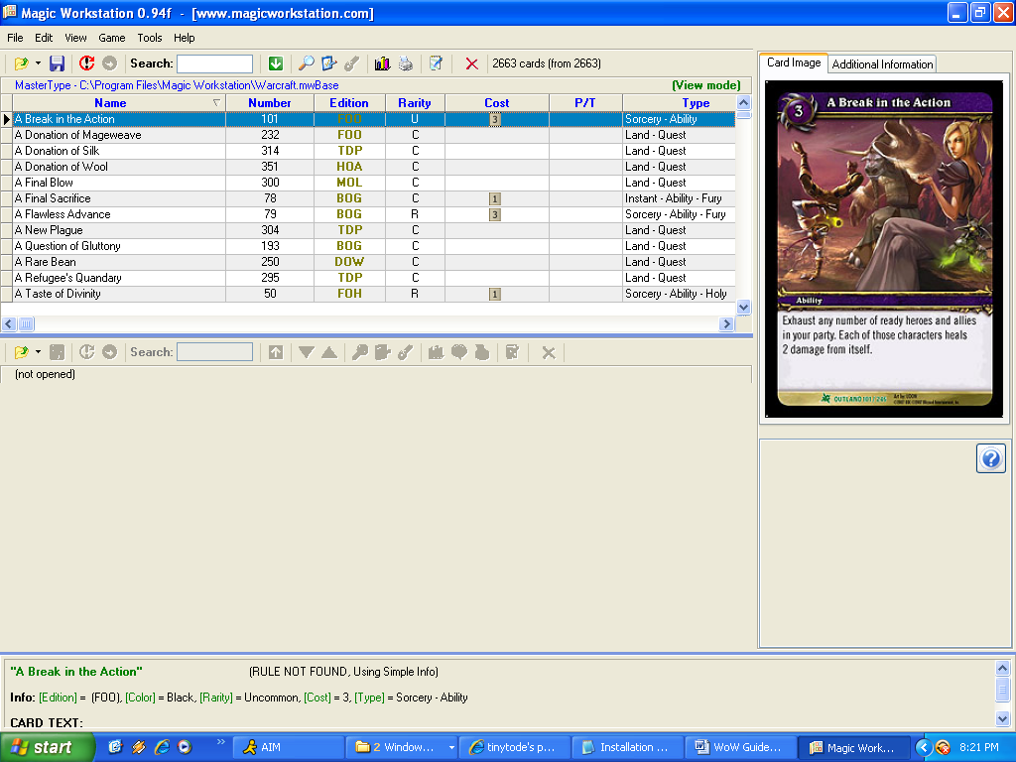

You are now done installing and are ready to begin building a deck.
Section 2
Utilizing Deck Builder Program

A) Creating a Deck

To begin, open the program called Magic Workstation. Once in the program, you can immediately begin to build a deck. I would recommend first switching to the Deck Builder view, as this screen makes building decks much easier. To do this, goto “View, Deck Edit Mode” (Ctrl F2). If done correctly, the screen should look like this:
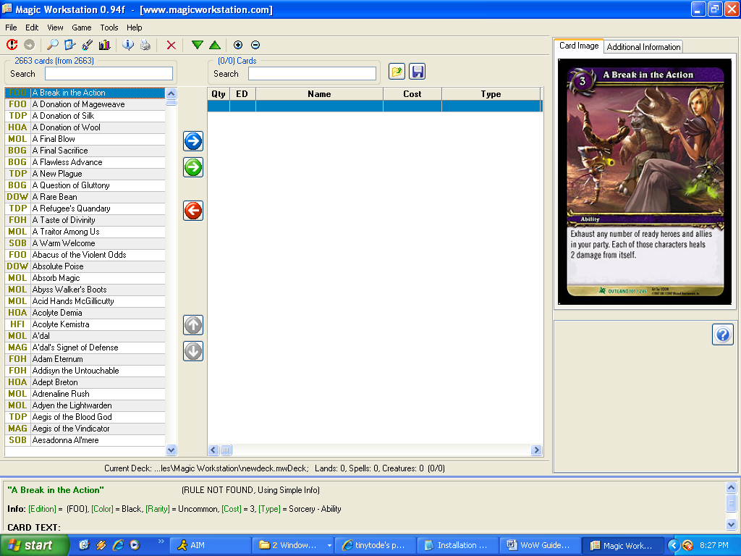

Once in this screen, goto “File, New Deck” (Ctrl N). You will be prompted to name your deck. If you plan on building a large number of decks, I would suggest giving your decks distinctive names. After you name your deck, click “Save”. You can now begin adding cards to your deck.

Section 2
Utilizing Deck Builder Program

A) Creating a Deck

As of right now, Magic Workstation does not have the best filtering system. Considering the program was made to play and build Magic: The Gathering decks, some things did not translate over so well to WoW. Even still, there are some features of the program that can still help. There is a rudimentary search feature (mostly by card name) that will help locate specific cards. I would suggest using a filtering database to help with deckbuilding. I personally use http://wowtcgdb.com; however, I do not run that website, and can answer no questions about it. So lets start building a deck.

First, for this example, I will be building a Traitor Kilzin deck. Again, I make no claim that this deck will work for you. This is only for illustrative purposes. So lets start by adding Kilzin to our sideboard. Putting a hero in the sideboard will make it easier later to find your hero card when playing against an opponent. So let’s search for Kilzin, by typing his name in here:

After you locate Kilzin, highlight his name in the list on the left, then click the green button to add him to the sideboard. The picture below details what the 3 main buttons do.

Adds cards to the main deck
Adds cards to sideboard

Removes cards from deck

After you add the hero to the sideboard, you can start adding cards to the main deck. After you add all the cards, you will have a deck that looks approximately like this:
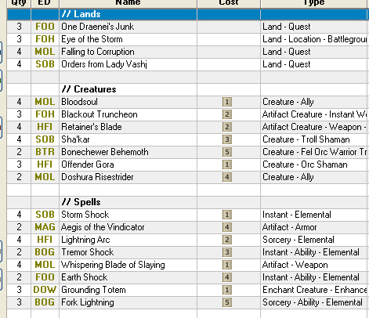
Section 2
Utilizing Deck Builder Program

B) Making a Side Board

After you make your deck, it’s important to also make a sideboard for that deck. If you have been following this guide, you should already have Kilzin in the sideboard. After you evaluate your deck, you should come up with a 10 card sideboard. I chose the following cards, but again that is only my preference. Please bear in mind that MWS does not know that sideboards need only be 10 cards. You can add as many cards, without limit, to your sideboard. Your deck will not be a tournament legal deck this way, but MWS is not a tournament. It’s a tool for testing, and when testing sometimes you may want to try out all your options. The sideboard is found immediately below the main deck in the same window. Here is what my sideboard looks like:
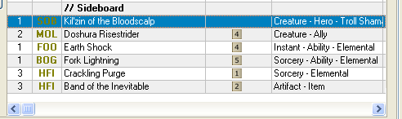

C) Copying a Deck

Now sometimes when you are playing with friends on MWS, they may like the deck you are playing. They may ask you for a copy of the deck to try out. There are two ways to send a deck. The first method is to locate the mwdeck file. Any person who has the most up-to-date version of the WoW patches can simply load any mwdeck file and instantly have a copy of your deck. Now some players may just want to see the decklist typed up. MWS allows for a very easy method to copy a deck to text. To do this, goto “Tools, Copy Deck to Clipboard”. A new window will pop up, and then you can click on the button called “Copy to Clip”. Presto, your deck is now on the clipboard and can be pasted anywhere you can paste info from the clipboard (email, IM, Facebook, etc).
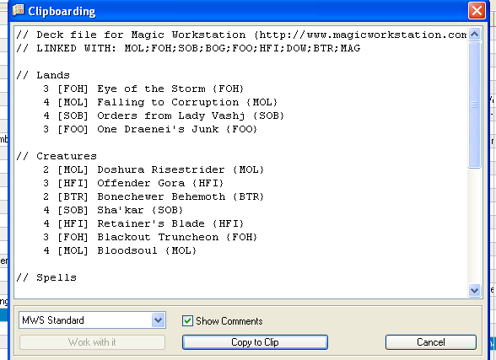
Section 3
Starting a Game Online

Now that we have made deck, it’s time to go play the deck against an opponent and see if it’s any good. This section will detail how to get a game going online. To begin, it’s now time to open the other file that came with the Magic Workstation program, called MWS Online Play.

A) Loading a Deck

Once you open the program, click “File, New Game” (F2). A new window will pop up that looks like this:
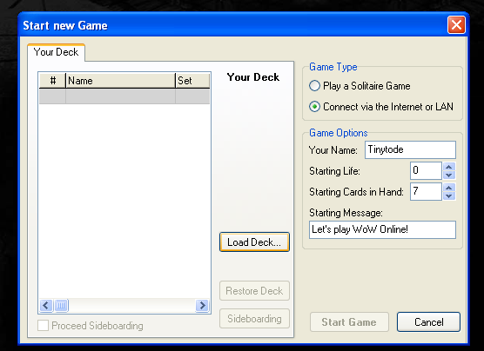

Click the button called “Load Deck”. Another window will pop up with a list of all mwdeck files you have created so far. If no files appear, browse to the location C:\Program Files\Magic Workstation. By default, all decks are saved here. So let’s select the Kilzin deck we just made. After loading the deck, the screen will change and now look like this.
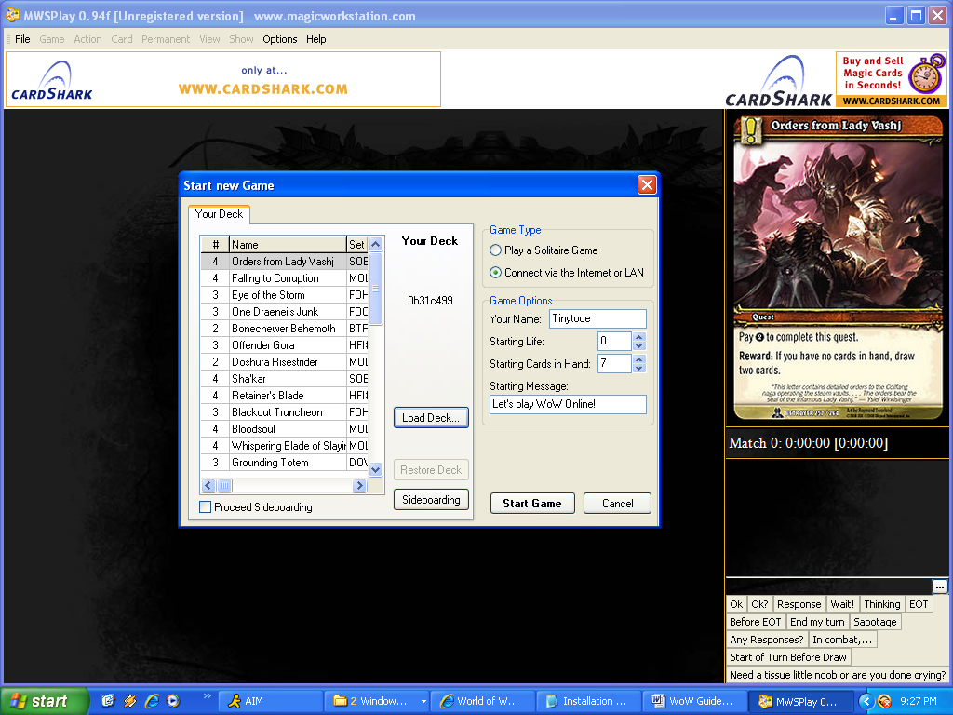
Section 3
Starting a Game Online

B) Creating a Username

After you load your deck, you can proceed to starting your game. However, I would recommend a few more steps. So next, let’s give ourselves a name. I chose to go by my handle, Tinytode. You can choose to make your name whatever you want, and you can change your name as much as you want. However, some players on MWS do not like to play random strangers, so you may want to stick with one name and build up a good reputation. Type your name in the location under “Game Options” called “Your Name”. While you are here, you can also set your Starting Cards in Hand (7 cards) and your Starting Life (WoW starts at 0 and counts damage on until you reach fatal damage). You can also add a starting message. This will appear every time you start a game with the opponent. This isn’t necessary, but I chose to type in a message as an example. Once you are satisfied with your name and deck, you can now proceed to finding a game.

C) Joining a Server

Before you click start game, make sure that the box called “Connect via the Internet or LAN” is checked off.

Now you can click the button on the bottom right called “Start Game”. Once you do, a new screen will appear. This screen allows you to select the server you want to play on. Magic Workstation comes with 2 preset servers: mwsplay.net & mwsgames.net. The majority of players will be found on mwsplay.net. However, the server can be pretty unstable. When that servers starts to “bug out” or “crash”, you may want to switch to a lesser known server. A list of servers to play on is available on my website. Please feel free to recommend any other servers. To add a server, click the button with that has three dots. A new window will pop up where you can enter any server names. Once on the list, you can then select that server from the drop down menu.
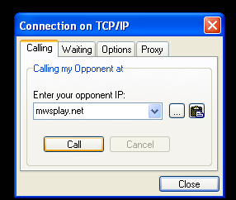
Section 3
Starting a Game Online

C) Joining a Server

For this example, we are going to select the mwsplay.net server. Once you have the name of the server in the dropdown window, click the button “Call”. A new window will pop up. This is the gaming window where you can host or join a game.
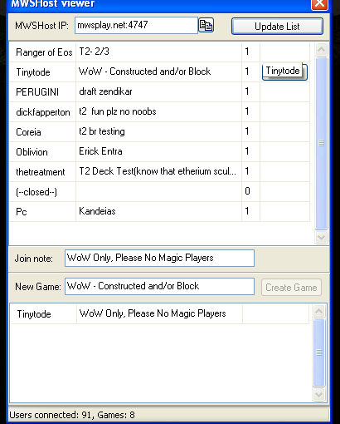

D) Joining / Hosting a Game

Once you are in this window, you can select to either join a pre-existing game or join a game already hosted. Before you join, be sure to type something in the Join Note box so that opponents will know you are playing WoW, and whether you are playing Block or Constructed. Then to join a game, click the button called “Join”. Be careful, the bulk of games on this server are for Magic: The Gathering. Look for a game with WoW or Warcraft in the name before clicking the join button. In the example above, I hosted a game with an example of what you should look for.

If you don’t see a WoW game, you can choose to host a game. To do this, type a message in the “New Game” box that indicates you are playing WoW and what version you are playing. Then, as players join the game, they will appear below your name with their join note. If the join note mentions WoW, you can then click the button called “Accept”. Your game will now begin.
Section 4
Playing a Game

This section will go over how to actually play the game once you have hosted the game. Bear in mind, these are only the bear necessities to play a game. You may learn other shortcuts from players as you go along. Let’s start by taking a look at what a game looks like. When you start, the screen should look like this:
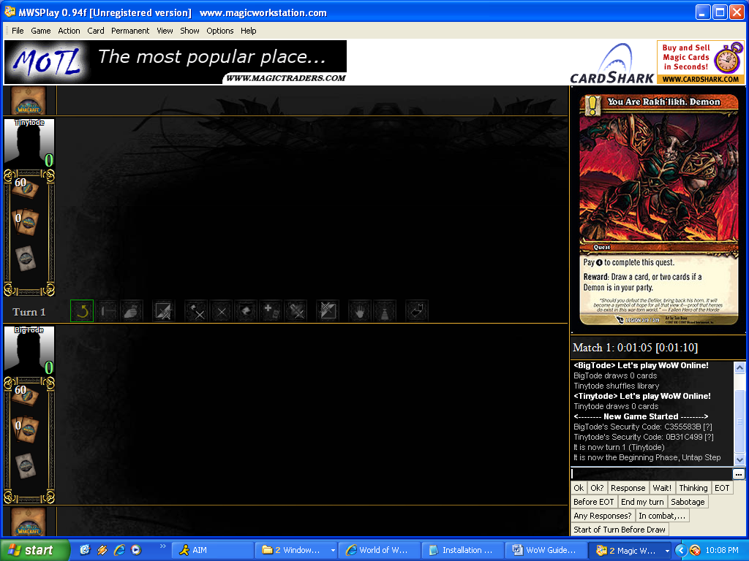

Your info will be on the bottom screen and your opponent’s will be on the top. The right side of the screen has the dialogue log that tracks each action as well as all anything you and your opponent has typed. Below the log, are quick text buttons. When you click a button, the pre-made text will become visible to you and your opponent. This is convenient when you want to indicate certain actions like responding to an opponent, or ending your turn.
- “Ok” – Use this when you want to indicate that your opponent can proceed without you responding.
- “Ok?” – Use this when you add a card to the chain, and want to know if your opponent is going to respond.
Section 4
Playing a Game

- “Response” – Use this when you want to respond to an action.
- “Wait!” – Use this when you want to tell your opponent to slow down and wait while you decide what you are going to do.
- “Thinking” – Use this when you are taking a long time and want to let your opponent know that you didn’t abandon the game and just need more time.
- “EOT” – Use this when you want to take an action during the end of turn phase.
- “Before EOT” – Use this when you want to respond to your opponent proceeding to the end of turn phase.
- “End my turn” – Use this when you want to proceed to your end of turn phase.

The card in the top right of the screen is a blown up image of the cards on the board. When you click on any card on the field or in your hand, an enlarged image will be shown here.

Once you have joined a game, it’s usually polite to say hello to your opponent. Next, you should reveal the hero you chose to play as. If you put your hero in your sideboard like I recommended, then click on “View, My Sideboard”. A window will pop up with all the cards listed in your sideboard.
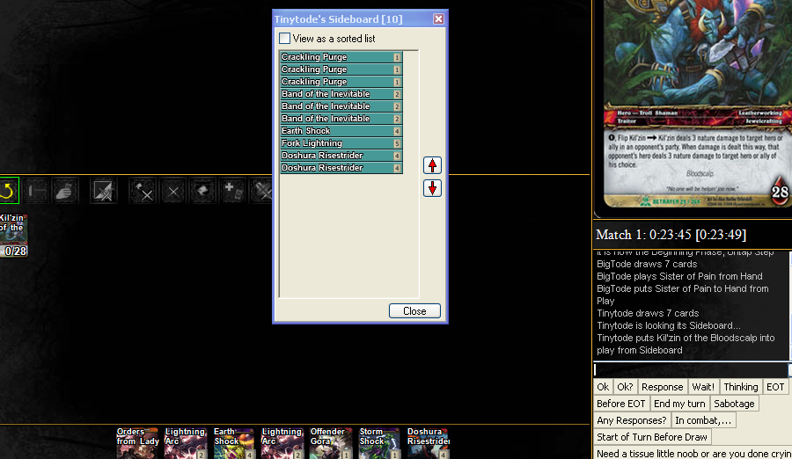
This window cannot be seen by your opponent. Click on your hero and drag the card into your field. You can now close your sideboard window.
Section 4
Playing a Game

Now I’ll go over a few necessary keyboard commands for playing a game:
- Ctrl I Roll a 20 sided Dice
- Ctrl M Draw your hand. If you do this again, you will take a mulligan and draw 1 less card (Stupid Magic Rules).
- Ctrl D Draw a card
- Ctrl S Shuffle your deck. The game also auto-shuffles your deck every time you look at your library.
- Ctrl R Undo the last draw (In case you draw too many cards)
- Ctrl U Ready all your cards

There are other command shortcuts, but most of those are exclusive to Magic and will not be used in WoW.

Once you are ready to begin playing, start by rolling a dice (Ctrl I). Highest number will get to start. Then you can draw your opening hand. (Ctrl M). If you don’t like your hand, draw another (Ctrl M). You will only have 6 cards at this point, so draw another card (Ctrl D). Now you can start playing.

Now I’ll go over commands for playing cards:
- Hold Alt and Left Click Mouse on a card to tap and untap the card.
- Ctrl Delete on card in play to send it to the graveyard.
- Ctrl O on a card in play to set counters on card (Will display yellow)
- Shift and Enter on a card in play to set a note (Use to indicate flipped Hero)
- Right Click on card in play and hold down. Then drag to another card to draw a red arrow to that card.
- Hold Shift, then Right Click on card in play and hold down. Then drag to another card to draw a yellow arrow to that card.
- Right Click on Avatar (Looks like a shadowy profile of a person on left side of screen) to assign damage. Track damage here rather than on your hero card, as counters become hard to see when they exceed 10.
- Hold Shift and Drag a card from hand on to field, to play a card face down.
- Hold Shift and Drag a card from the library icon on left into play (to play a card from library face down)
Other commands can become visible when you right click on the card.
Section 5
FAQ’s

Why are the images showing squished together?

This is because the theme file did not install correctly. You will need the WoW Theme in order to be able to see the full card image. To correct this, the easiest solution is to reinstall the theme file which can be done from here: http://mws.infogathering.com/files/Themes.exe

Why are the images showing as black squares?

This is due to the card in the masterbase not linking to the most up-to-date custom set file. In the Magic Workstation deckbuilding program, look at the 3 letter code that is the set edition for the card that is appearing black. Then, from my webpage, download and reinstall the Archive Version that coincides with the 3 letter set edition. All archive files are located here:
http://mws.infogathering.com/downloads.php

Section 6
Version History

Version 1.0 – Created the document. Still need to improve some sections and add the FAQ’s.

Version 2.0 – Updated through Naxxramas Raid Deck. Updated links. Corrected some typos.

Version 3.0 – Updated through Wrathgate. Updated links.

Version 10.0 – Skipped ahead so Guide Version Coincides with latest patch version. Updated through Icecrown. Updated links. Began adding FAQs.

